2.8 Click Sensor Hub

Working with our sponsor, Dr. Kemp at NXP, and our faculty advisor, Dr. William Stapleton at Texas State University, we have designed an add-on board for the FRDM-KL46Z (a development platform built on the Arm® Cortex®-M0+ processor). Our board will convert 24 out of the 64 pins available in the KL46Z to 4 MikroBus Standard sockets. These 4 sockets facilitate communication with 600+ Click Sensors. The user simply connects the KL46Z to our board, connects any combination of Clicks into the sockets and is ready to begin developing.

Activity and resource planning​ for meeting deadlines

Document Full Functionality Test

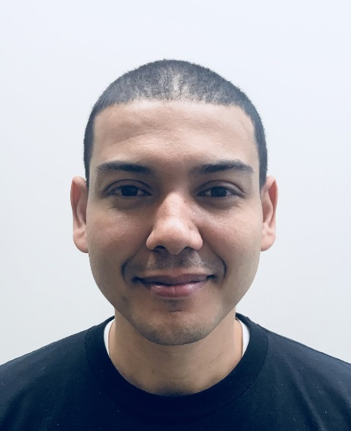

Mohamed Sghari

Alfonso de la Morena [PM]

PCB Design/Edits in Eagle CAD

Document Hardware Functionality Test

Soldering prototype boards

Stretch – Instructional web articles for hardware usage

Stretch – Website Design (CSS/HTML)

Document 10 Click Validation Test

Presentation, poster board, user guide and T-shirt design

Mbed code to interfacing between board and sockets

Stretch – Manage cloud hosting for website

Stretch – Front/back end design for website

Mbed code to interfacing between board and sockets

Dylan Dean